WORKSHEET

PRACTICAL- 3

# NAME: Adya Singhal

# ROLL No.: 2410110027

# SNU-Id: as401@snu.edu.in

# COURSE: MED201

# BATCH: PA

# STREAM: BTech CSE

**QUESTION 1**

Perform the simulation in LAMMPS to obtain the following mechanical properties of Aluminium:

1. Young’s modulus
2. Yield strength
3. Strain at which the plastic deformation starts.
4. Modulus of resilience from the stress-strain curve of Aluminium.

Compare the values of (a) and (b) with the reference value.

Provide the link to the reference that you followed.

Provide the following simulation details:

1. equilibration temperature- Is the equilibration temperature equal to the desired temperature? Specify the difference in two temperatures.
2. timestep used
3. strain rate
4. number of iterations
5. strain applied in each step

**ANSWER 1**

1. Young's modulus can be calculated from the linear part of the stress-strain curve in the elastic region. The script records the strain and stress data into a file (Al_SC_100.def1.txt).

From the above data we know that the graph would appear linear till a strain of 0.14 and stress of 7.8139899 GPa. We know, Young’s Modulus is given by:

Young’s Modulus= Stress/Strain

Here, stress=7.8139899 GPa and strain=0.14

Y=7.8139899GPa /0.14=55.8GPa

Therefore, Young’s Modulus is given by 55.8 GPa.

1. Yield strength is the maximum stress a material can withstand before it permanently deforms.

Here, Yield strength is given by 7.8139899 GPa.

1. Strain at which the plastic deformation starts is 0.14.
2. The modulus of resilience is a mechanical property that measures how much energy a material can absorb without permanently deforming.

It is given by the area under the stress-strain curve up to the elastic limit.

Therefore, Area= ½*7.814*10^9*0.14

= 5.47*10^8

The modulus of resilience equals 5.47*10^8 N/m^2.

On comparing the values of (a) and (b) with the reference values we find that:

Value Obtained for Young’s Modulus: 55.8 GPa

Reference value for Young’s Modulus: 70 GPa

Value Obtained for Yield Strength: 7.8139899 GPa

Reference value for Yield Strength: 300 MPa

Link to references followed: <https://www.mit.edu/~6.777/matprops/aluminum.htm>

https://www.cavs.msstate.edu/icme/code/lammps/tutorials/lammps/tutorial1.php

SIMULATION DETAILS:

1. The equilibration temperature in the simulation is set to 300 K.

It is specified in the ‘velocity’ and ‘fix commands as shown above. There is no difference between the equilibration temperature and the desired temperature since both are set to 300K.

1. Timestep used is 0.002ps as shown below:

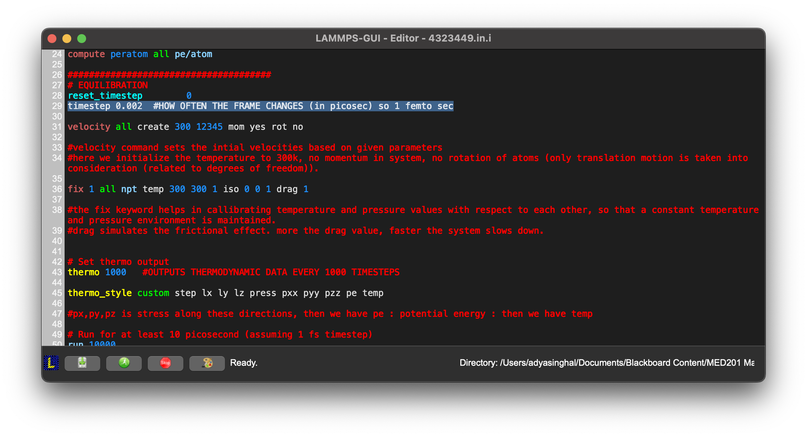

1. Strain rate is equal to 1.0 × 10^10 s^-1 as shown below:

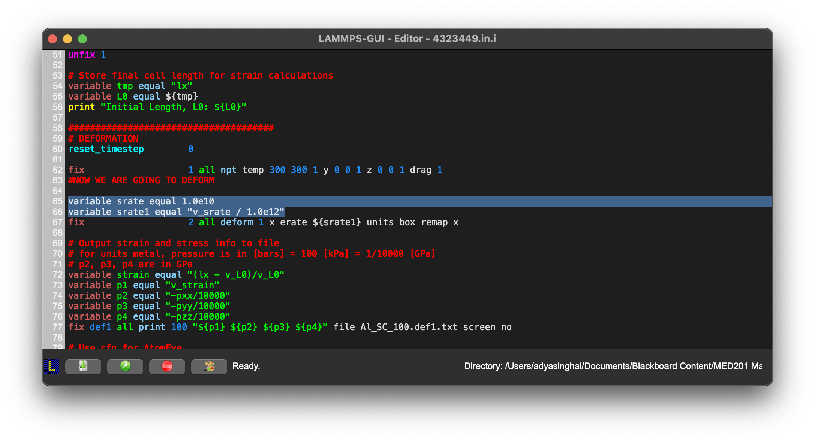

1. Number of iterations is equal to 10,000. We can see this from both the input and the output.

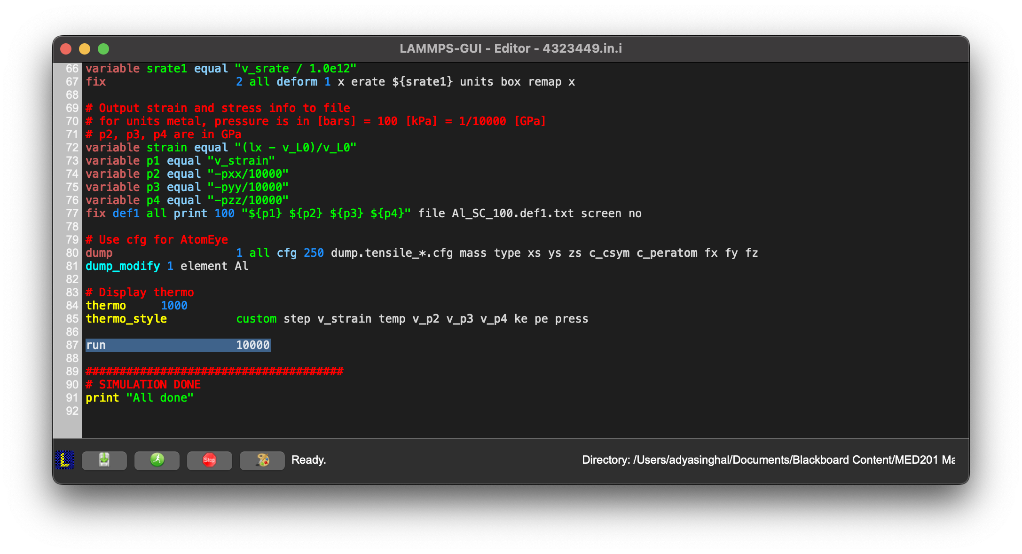

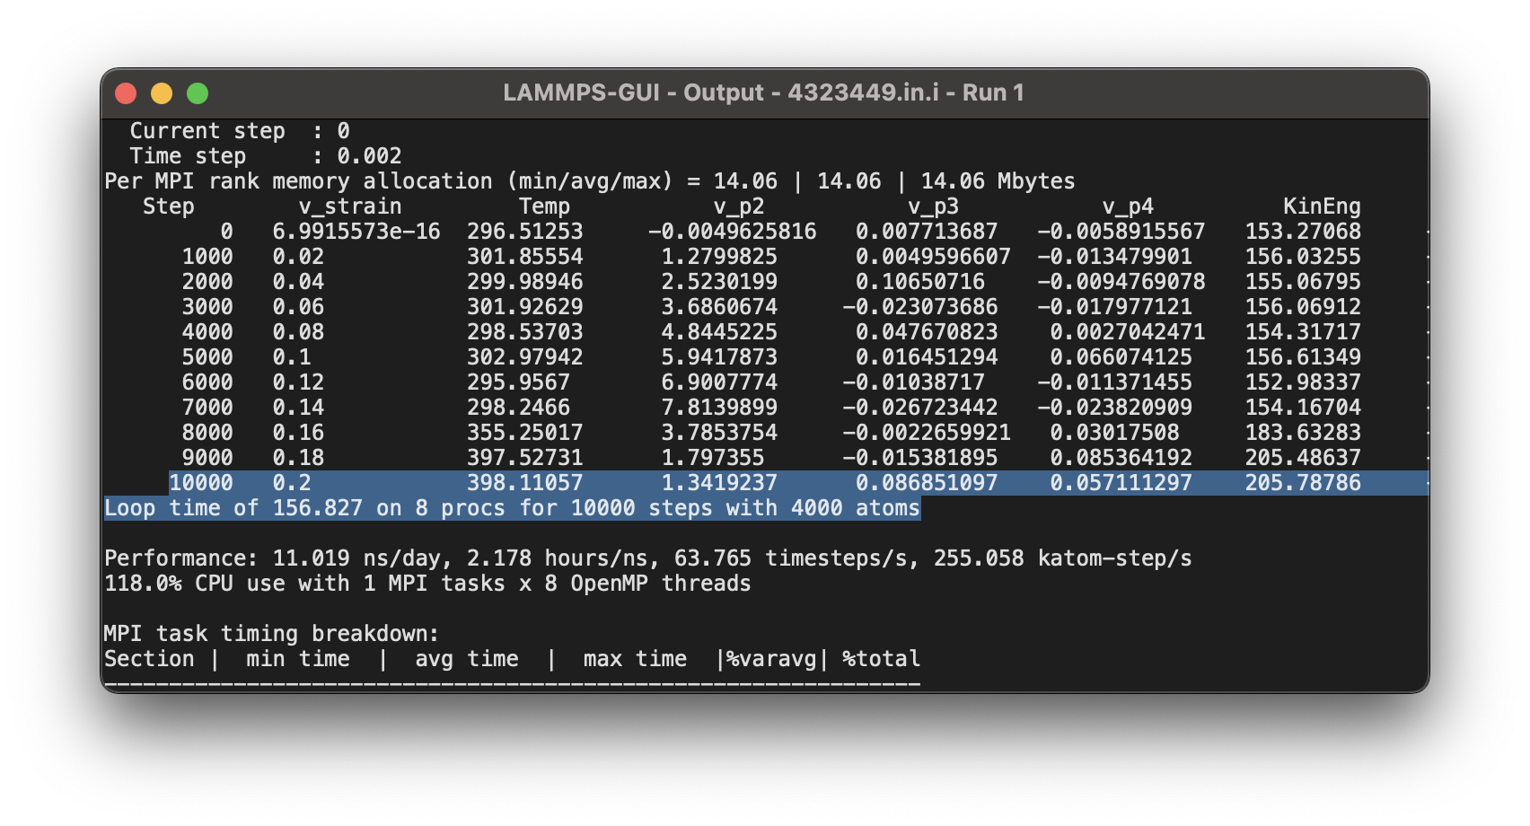

1. Strain applied in each step is given by:

strain applied per step=strain rate*time step

We know, strain rate= 1.0 * 10^10 s^-1

Time step= 2 * 10^-15 s

Therefore, strain applied in each step is 2*10^-5.

**QUESTION 2**

Change the input file and compute the elastic modulus in compression for Aluminium.

Specify the following:

1. Modulus of compression
2. Is there a sharp yield strength in compression?

**ANSWER 2**

1. Modulus of compression is given by:

Modulus of Compression = Compressive Stress / Compressive Strain

We need the compressive stress and compressive strain in order to compute the modulus of compression.

In order to obtain the compressive stress and strain, we make the following changes to the input file:

1. Deformation Direction: The code was changed to simulate compression in the x-direction by setting flip yes in the deform fix command:



1. Strain Rate: The strain rate variable was modified to have a negative value for compression:



1. Compressive Strain: The strain variable was redefined to compute compressive strain:



1. Output: The output file was redirected to save compression data:



On running the LAMMPS code after making the changes stated above, we get the following results:

The compressive stress (p2) was plotted against the compressive strain (p1) to generate the stress-strain curve for aluminium under compression. This curve was analysed to identify the elastic regime, which is typically characterized by a linear relationship between stress and strain.

The slope of the linear part of the stress-strain curve in the elastic regime gives the elastic modulus (Young's modulus) in compression. This is calculated by fitting a line to the initial portion of the stress-strain curve where the deformation is recoverable.

The elastic modulus was found to be 100GPa, which is the slope of the linear portion of the stress-strain curve.

1. The analysis of the stress-strain curve does not indicate a sharp yield strength in compression for aluminium.

Instead, the curve shows a gradual transition from elastic to plastic deformation, which is typical for many metals under compression.

**QUESTION 3**

Change the input file and compute the bulk modulus of Aluminium (refer to course slides for the formula).

Specify the value of bulk modulus.

Compare this value with the reference value. Provide the link to the reference that you followed.

**ANSWER 3**

Bulk modulus is given by the formula:

K= − ΔP/( ΔV/V0)

We need to find values of ΔP, ΔV and V0 from the output obtained:

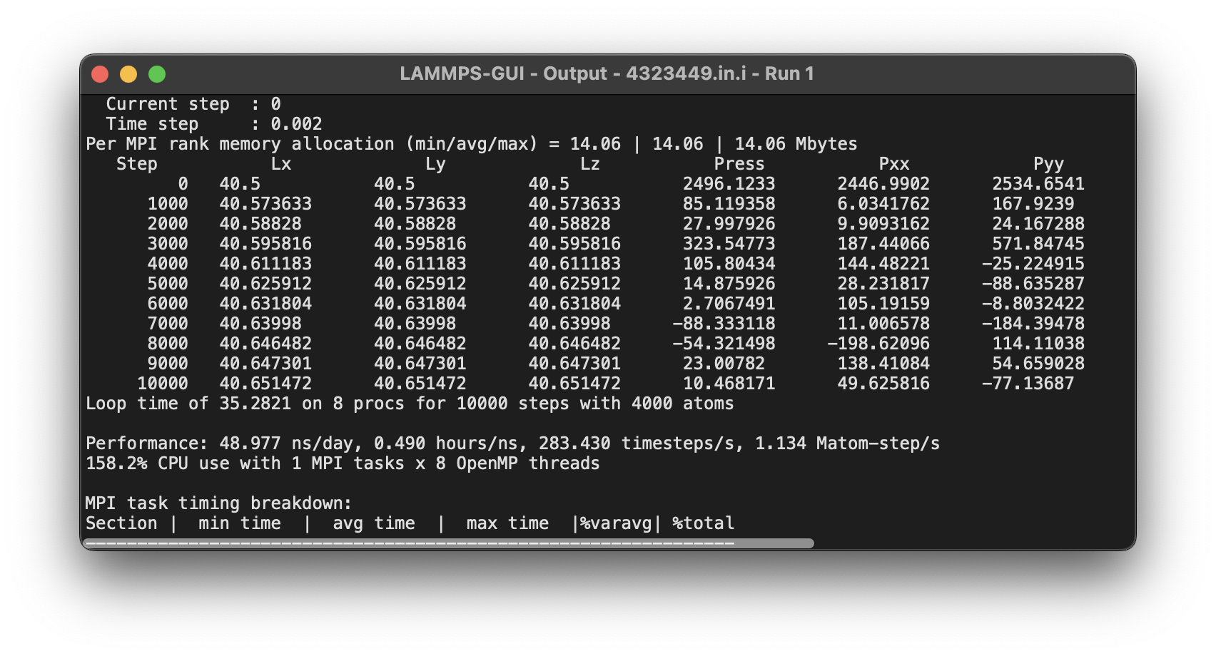

From this data, we obtain the following:

Initial Pressure (P0): 2496.1233 Pa

Initial Volume (V0): 40.5 m³

Final Pressure (Pf): 10.468171 Pa

Final Volume (Vf): 40.6514718901646 m³

Therefore,

ΔP = Pf −P0 = 10.468171−2496.1233 = -2485.655129 Pa

ΔV = Vf −V0 = 40.6514718901646−40.5 = 0.1514718901646 m^3

K = -(-2485.655129/(0.1514718901646/40.5))= 6646050.37737468 Pa

The value of bulk modulus we obtain is 66GPa.

The reference value of bulk modulus of Al is 76GPa.

Link to reference followed: https://periodictable.com/Properties/A/BulkModulus.al.html